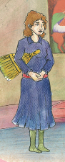  Sweeper (supurgeci) | Cleans the Cem area
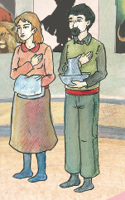  Jug server (Ibrikci) | Wash hands
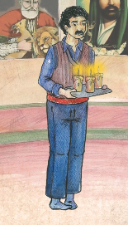  Candle lighter (cerag) | Lights the 3 candles
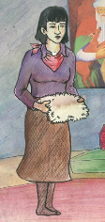  Fleece keeper (postcu) | Says a prayer
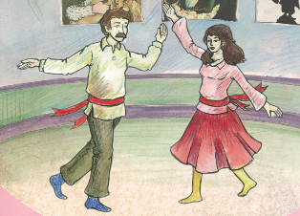  Semah performers | Perform the semah dance
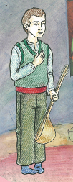Musician (zakir) | Plays the saz and sits next to the dede
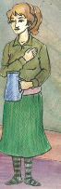Water server (sakkaci) | Serves the water
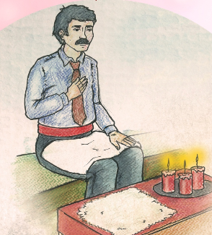  Pir (dede/ana) | Leader of the Cem
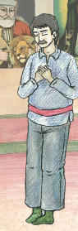  Guide | The guide sits beside the pir and helps him
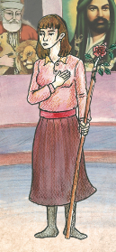  Cem Keeper (Gozcu) | Helps everyone to perform their services
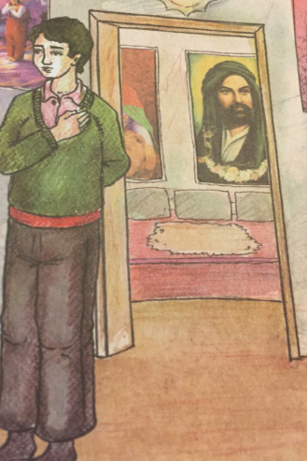Door keeper  (Kapici) | Keeps the doors closed and opens them at the end
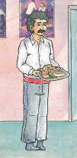  Food server (lokmaci) | Shares everybody’s food

